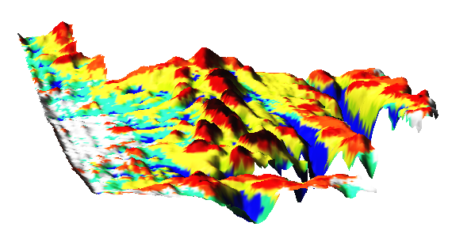

**Accuracy of Geomorphologic Phonotypes (Geomorphons) Technique**

**IN GrassGIS**

March 31, 2016

Travis Vanos

# Table of Contents

DEM model of Kriged data 2

R.Geomorphon Computational settings (Outer Search, Inner Search, Flatness, Flatness distance) 4

Accuracy of Geomorphon to Known Digital Elevation Model 5

Kriged Data 2m resolution (Lag = 25, Lag Tolerance = 50, Min Neighbours = 20, Max Neighbours = 200) 5

Kriged Data 3m resolution(Lag = 30, Lag Tolerance = 50, Min Neighbours = 20, Max Neighbours = 200) 11

Kriged Data 3m resolution (Lag = 25, Lag Tolerance = 50, Min Neighbours = 25, Max Neighbours = 250) 14

Kriged Data 5m resolution (Lag = 25, Lag Tolerance = 50, Min Neighbours = 20, Max Neighbours = 200) 17

Kriged Data 10m resolution (Lag = 25, Lag Tolerance = 50, Min Neighbours = 25, Max Neighbours = 250) 19

# List of Figures

Figure 1 Symbology of Geomorphon classification (Default Grass) 2

Figure 2 Exaggerated z Values Raw CulOwned Field DEM 3

Figure 3 R.Geomorphon Options in GrassGIS 4

# List of Tables

Table 1 DEM model of Kriged data at different resolutions 2

Table 2 2m Resolution 3D and 2D models 5

Table 3 3m Resolution 3D and 2D models 11

Table 4 3m Resolution 3D and 2D models 14

Table 5 5m Resolution 3D and 2D models 17

Table 6 10m Resolution 3D and 2D models 19

# DEM model of Kriged data

|  |  |  |  |  |
| --- | --- | --- | --- | --- |
| **Kriged 10m (25/50/25/250)** | **Kriged 5m (25/50/20/200)** | **Kriged 3m (25/50/25/250)** | **Kriged 5m (30/50/20/200)** | **Kriged 2m (25/50/20/200)** |
|  |  |  |  |  |

Table DEM model of Kriged data at different resolutions

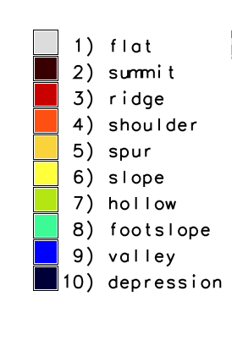

Figure 1 Symbology of Geomorphon classification (Default Grass)

|  |
| --- |
|  |

Figure 2 Exaggerated z Values Raw CulOwned 2011 Field DEM

# R.Geomorphon Computational settings (Outer Search, Inner Search, Flatness, Flatness distance)

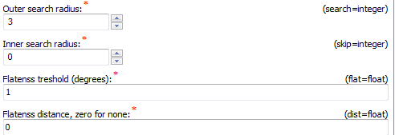

Figure R.Geomorphon Options in GrassGIS

**DEM**

Input Digital Elevation Model. Data can be of any type and any projection. During calculation DEM is stored as floating point raster.

**Search**

Determines length on the geodesic distances in all eight directions where line-of-sight is calculated. To speed up calculation is determines only these cells which centers falls into the distance

**Skip**

Determines length on the geodesic distances at the beginning of calculation all eight directions where line-of-sight is yet calculated. To speed up calculation this distance is always recalculated into number of cell which are skipped at the begining of every line-of-sight and is equal in all direction. This parameter eliminates forms of very small extend, smaller than skip parameter.

**Flat**

The difference (in degrees) between zenith and nadir line-of-sight which indicate flat direction. If higher threshold produce more flat maps. If resolution of the map is low (more than 1 km per cell) threshold should be very small (much smaller than 1 degree) because on such distance 1 degree of difference means several meters of high difference.

**Distance**

>Flat distance. This is additional parameter defining the distance above which the threshold starts to decrease to avoid problems with pseudo-flat line-of-sights if real elevation difference appears on the distance where its value is higher DO POPRAWKI

# Accuracy of Geomorphon to Known Digital Elevation Model

## Kriged Data 2m resolution (Lag = 25, Lag Tolerance = 50, Min Neighbours = 20, Max Neighbours = 200)

Table 2 2m Resolution 3D and 2D models

|  |  |
| --- | --- |
| r.geomorphon Settings ***(Search, Skip, Flat, Distance)*** | 3D Model Geomorphon 2D model |
| 150  25  1  75 |  |
| 200  25  1  50 |  |
| 250  25  1  25 |  |
| 250  25  1  75 |  |
| 250  55  1  75 |  |
| 250  75  1  105 |  |
| 250  75  1  125 |  |
| 300  25  1  100 |  |
| 300  35  1  100 |  |
| 350  55  1  100 |  |

## Kriged Data 3m resolution(Lag = 30, Lag Tolerance = 50, Min Neighbours = 20, Max Neighbours = 200)

Table 3m Resolution 3D and 2D models

|  |  |  |
| --- | --- | --- |
| r.geomorphon Settings ***(Search, Skip, Flat, Distance)*** | 3D Model Geomorphon 2D model | |
| 150  25  1  15 | |  |
| 150  25  1  50 | |  |
| 250  25  1  50 | |  |
| 250  5  1  25 | |  |
| 350  15  1  15 | |  |

## Kriged Data 3m resolution (Lag = 25, Lag Tolerance = 50, Min Neighbours = 25, Max Neighbours = 250)

Table 3m (25,50,25,250) Resolution 3D and 2D models

|  |  |
| --- | --- |
| r.geomorphon Settings ***(Search, Skip, Flat, Distance)*** | 3D Model Geomorphon 2D model |
| 100  5  1  25 |  |
| 350  15  1  50 |  |
| 250  15  1  10 |  |
| 250  15  1  50 |  |

## Kriged Data 5m resolution (Lag = 25, Lag Tolerance = 50, Min Neighbours = 20, Max Neighbours = 200)

Table 5m Resolution 3D and 2D models

|  |  |
| --- | --- |
| r.geomorphon Settings ***(Search, Skip, Flat, Distance)*** | 3D Model Geomorphon 2D model |
| 150  10  1  20 |  |
| 250  15  1  50 |  |
| 300  15  1  25 |  |

## Kriged Data 10m resolution (Lag = 25, Lag Tolerance = 50, Min Neighbours = 25, Max Neighbours = 250)

Table 10m Resolution 3D and 2D models

|  |  |
| --- | --- |
| r.geomorphon Settings ***(Search, Skip, Flat, Distance)*** | 3D Model Geomorphon 2D model |
| 150  10  1  50 |  |
| 250  10  1  25 |  |
| 250  10  1  50 |  |
| 350  10  1  25 |  |